Target SQL Business Case

Problem Statement:
Target is a globally renowned brand and a prominent retailer in the United States. Target makes itself a preferred shopping destination by offering outstanding value, inspiration, innovation and an exceptional guest experience that no other retailer can deliver.
This particular business case focuses on the operations of Target in Brazil and provides insightful information about 100,000 orders placed between 2016 and 2018. The dataset offers a comprehensive view of various dimensions including the order status, price, payment and freight performance, customer location, product attributes, and customer reviews.
By analysing this extensive dataset, it becomes possible to gain valuable insights into Target's operations in Brazil. The information can shed light on various aspects of the business, such as order processing, pricing strategies, payment and shipping efficiency, customer demographics, product characteristics, and customer satisfaction levels.
Assuming I am a data analyst/ scientist at Target, I have analysed the given dataset to extract valuable insights and provided actionable recommendations.

The data is available in 8 different csv files:

- customers.csv
- geolocation.csv
- order_items.csv
- payments.csv
- reviews.csv
- orders.csv
- products.csv
- sellers.csv

Dataset schema:

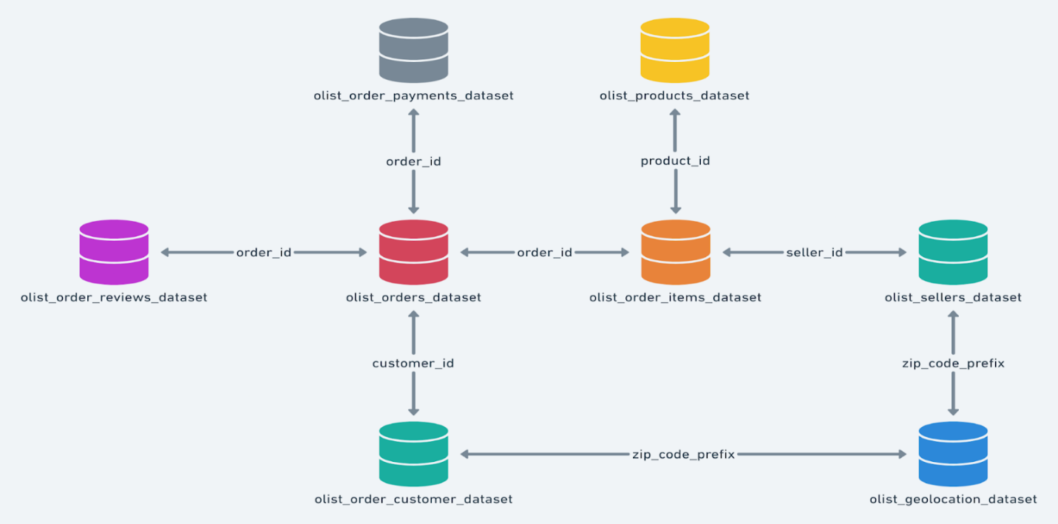

THE QUERIES AND THEIR SOLUTIONS ALONG WITH SCREENSHOTS OF THE OUTPUT ATTACHED ARE AS FOLLOWS:

I. Import the dataset and do usual exploratory analysis steps like checking the structure & characteristics of the dataset.
A. Data type of all columns in the “customers” table.
ANSWER :
select column_name , data_type
from `ecommerce-459515.target.INFORMATION_SCHEMA.COLUMNS`
where table_name = 'customers'

INSIGHT: We can see that most of the columns are string type.

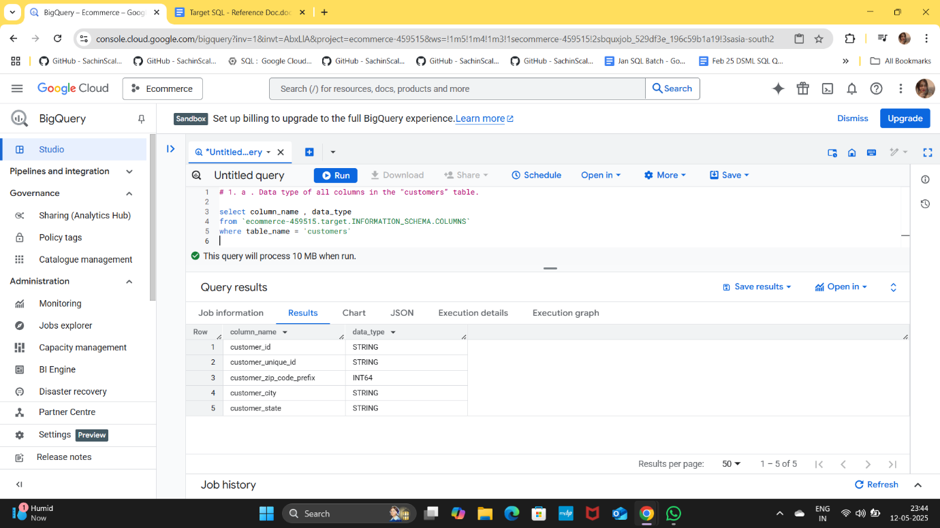

- Get the time range between which the orders were placed.

ANSWER: select min(order_purchase_timestamp) as first_order,
max(order_purchase_timestamp) as last_order

from `target.orders`

INSIGHT: The first order was placed on 2016-09-04 at 21:15:19 UTC and the last order was placed on 2018-10-17 at 17:30:18 UTC.
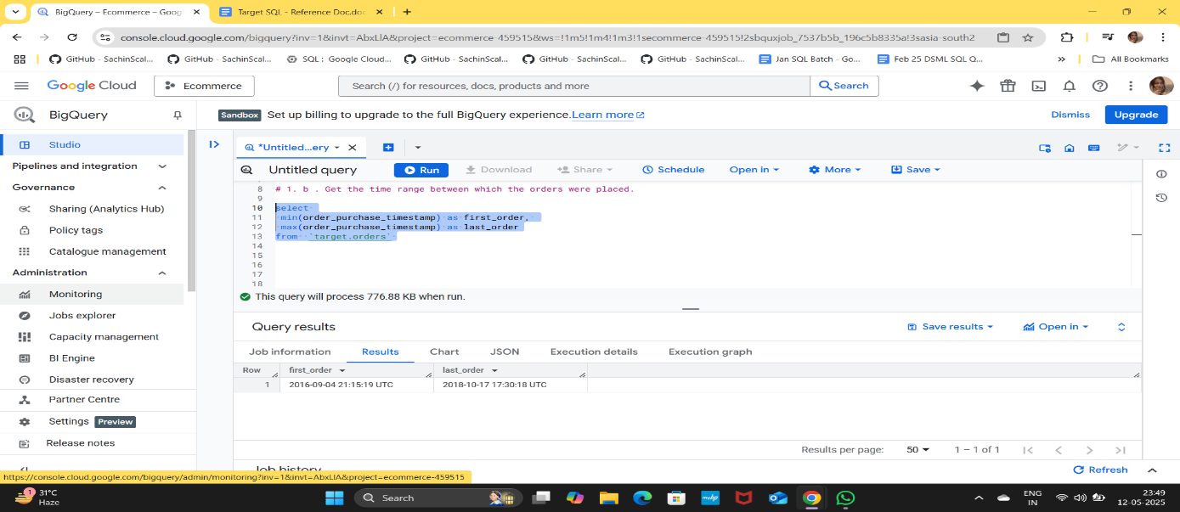

- Count the Cities & States of customers who ordered during the given period.

ANSWER: select count(distinct customer_city) as city_cnt,
count(distinct customer_state) as state_cnt
from `target.orders` o INNER JOIN `target.customers` c
USING(customer_id)

INSIGHTS: It is given that there are 4,119 unique cities and 27 unique states where customers placed orders during the specified period.

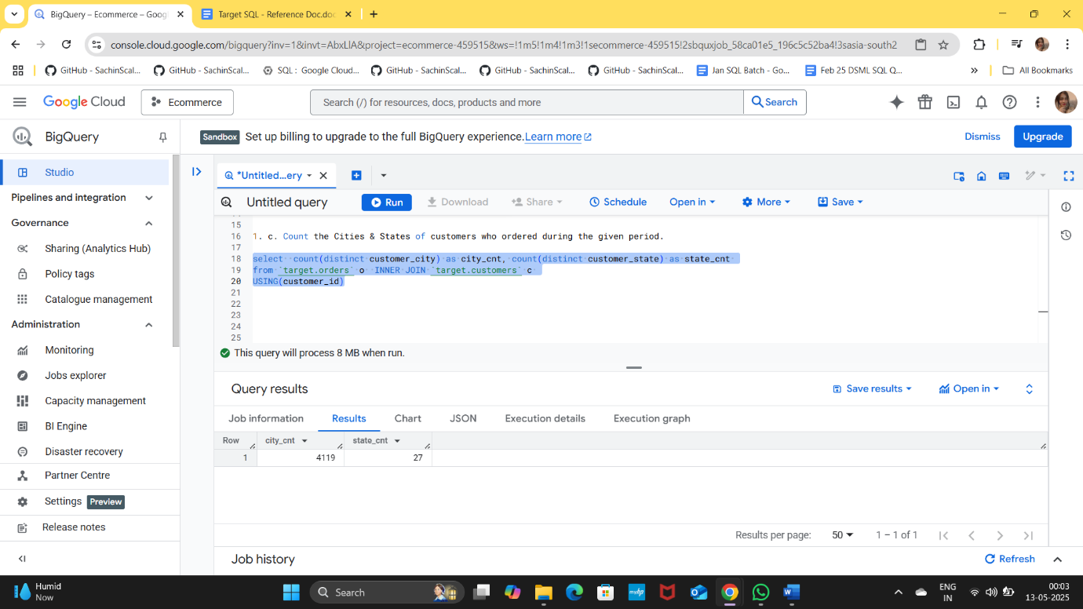

II. In-depth Exploration:

- Is there a growing trend in the no. of orders placed over the past years?

ANSWER:
select
extract(year from order_purchase_timestamp) as yr,
count(*) as orders_count from `target.orders`
group by yr order by yr

INSIGHTS:
The data shows a significant growth trend from 2016 to 2018. Starting with 329 in 2016, the numbers increased to 45,101 in 2017 which represents a dramatic increase of approximately 13,700% compared to 2016, showcasing a robust expansion in market presence and customer acquisition and further to 54,011 in 2018, reflecting a continued growth of about 20% from 2017, indicating sustained interest and engagement from customers.

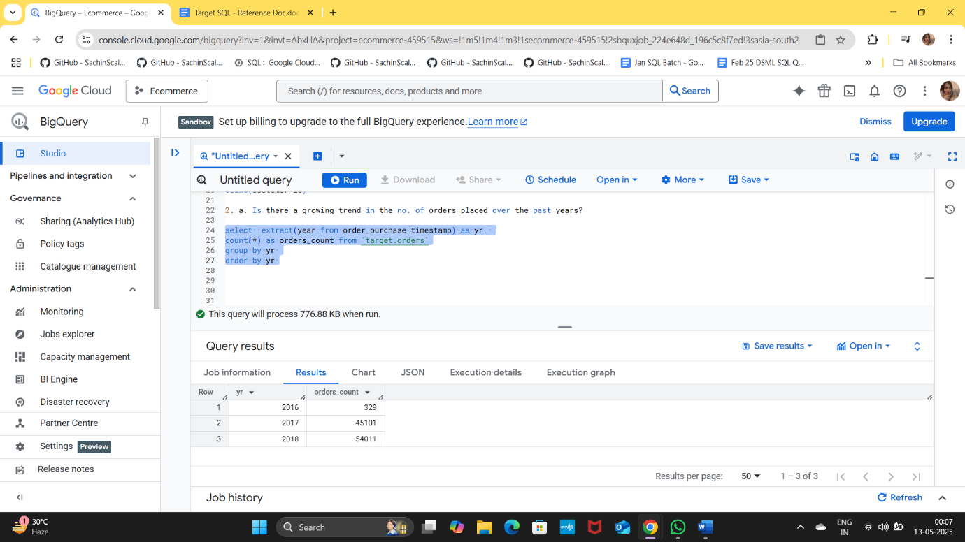

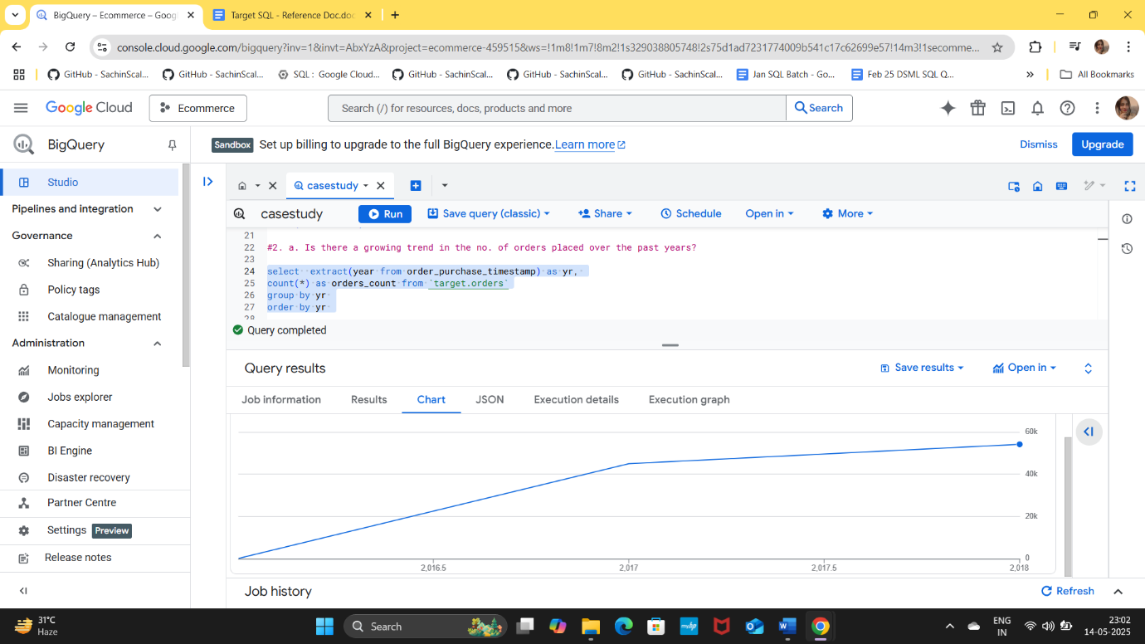

- Can we see some kind of monthly seasonality in terms of the no. of orders being placed?

ANSWER:
select extract(year from order_purchase_timestamp) as yr,
extract(month from order_purchase_timestamp) as mnth,
count(*) as orders_count
from `target.orders`
group by 1,2 order by 1,2 ;
INSIGHTS:
- The highest number of orders occurred in February with 7211 orders, making it the peak month for orders in 2018.
- There is a noticeable decline in orders starting from May, with a drastic drop in August and September, indicating a significant decrease in customer engagement or possible seasonal effects.
- The months of January, February, and March show relatively high order volumes, while the latter half of the year (especially August and September) shows a sharp decline.
- The peak in orders for 2018 occurred in February.
- The data suggests that there may be seasonal trends affecting order placements, with a significant drop in the latter months of the year. Further investigation into external factors (such as marketing campaigns, holidays, or product launches) may provide insights into these trends.

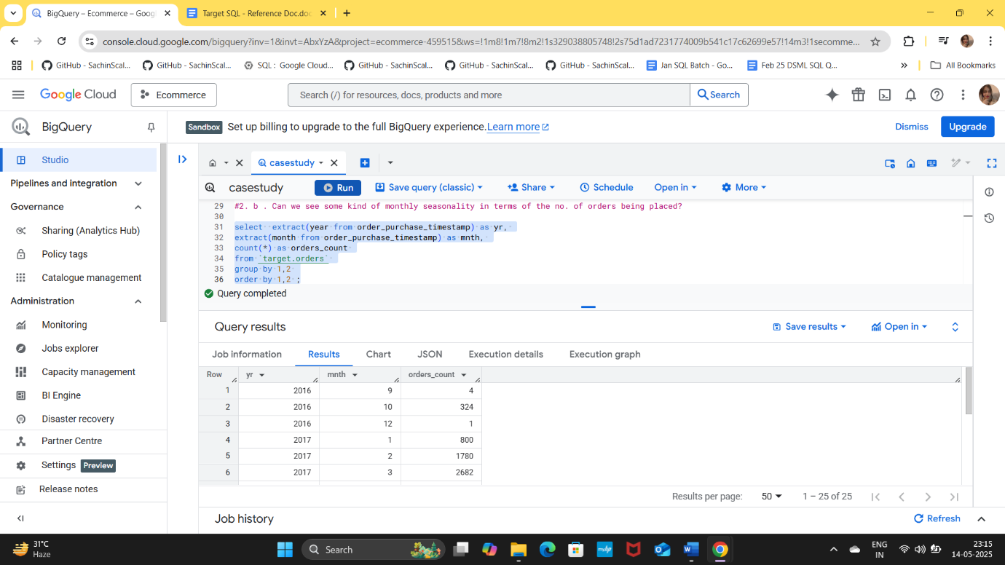

- During what time of the day, do the Brazilian customers mostly place their orders? (Dawn, Morning, Afternoon or Night)?

- 0-6 hrs : Dawn
- 7-12 hrs : Mornings
- 13-18 hrs : Afternoon
- 19-23 hrs : Night

ANSWER:

select
CASE WHEN extract(hour from order_purchase_timestamp) BETWEEN 0 and 6 THEN 'Dawn'
WHEN extract(hour from order_purchase_timestamp) BETWEEN 7 and 12 THEN 'Mornings'
WHEN extract(hour from order_purchase_timestamp) BETWEEN 13 and 18 THEN 'Afternoon'
WHEN extract(hour from order_purchase_timestamp) BETWEEN 19 and 23 THEN 'Night'
END as time_of_day,
count(*) as num_orders from `target.orders`
group by 1
order by 2 desc;

INSIGHTS:

Brazilian customers mostly place their orders during the Afternoon, with a significant number of orders also occurring at Night. The data indicates that these two time periods are the most active for order placements.

- Afternoon (13-18 hrs): This time period sees the highest volume of orders, indicating that customers prefer to shop during the afternoon hours when they are likely to have more leisure time.
- Night (19-23 hrs): Following the afternoon, the night also shows a substantial number of orders, suggesting that many customers continue to shop after their daily activities.
- Mornings (7-12 hrs): While there is some activity during the morning, it is less than both the afternoon and night, indicating that customers may be less inclined to place orders early in the day.
- Dawn (0-6 hrs): This time period has the least number of orders, reflecting that very few customers are active during these early hours.

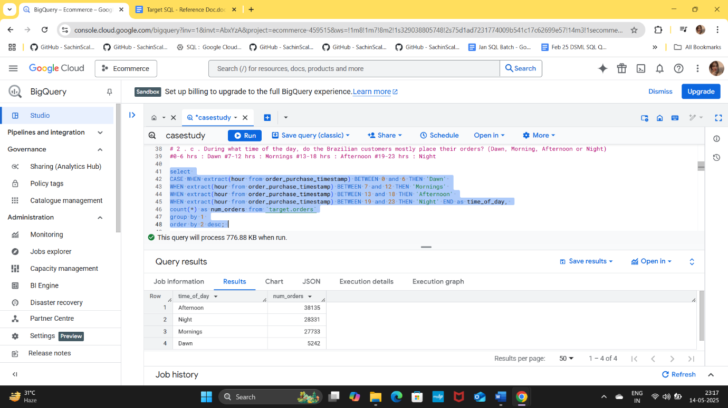

- Evolution of E-commerce orders in the Brazil region:

- Get the month-on-month no. of orders placed in each state.
ANSWER:
select extract(year from order_purchase_timestamp) as year,
extract(month from order_purchase_timestamp) as mnth,
customer_state,
count(*) as num_orders
from `target.orders` o
INNER JOIN `target.customers` c
USING(customer_id)
group by 1,2,3
order by 4 desc;

INSIGHTS:

Peak Months:
  - The month with the highest orders for PR is July with 523 orders.
  - For RS, the peak month is April with 488 orders.
  - MG only has data for September.
Low Activity:
  - There are no recorded orders for MG in the other months, indicating a potential area for growth or marketing focus.

Order Distribution:
  - PR shows consistent ordering behaviour across multiple months, while MG and RS have more sporadic ordering patterns.

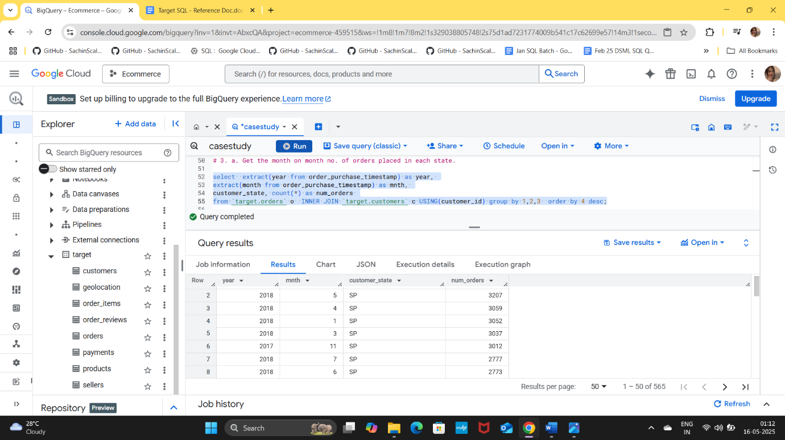

- How are the customers distributed across all the states?

ANSWER:
select COUNT(DISTINCT customer_id) AS UniqueCustomers,
customer_state
from `target.customers`
group by 2

INSIGHTS:
- Highest Customer Count: The state of (SP) has the highest number of unique customers at 41,746, indicating a strong market presence and customer base in this region.
- Significant Markets: Other states with notable customer counts include:
  - (RJ): 12,852 customers
  - (MG): 11,635 customers
  - (RS): 5,466 customers
  - (PR): 5,045 customers
  - (SC): 3,637 customers
- Lower Customer Counts: Some states have significantly lower customer counts, such as:
  - (AC): 81 customers
  - (RR): 46 customers
  - (AP): 68 customers
- Diverse Market Presence: The data shows that customers are distributed across all 27 states, indicating a diverse market presence.

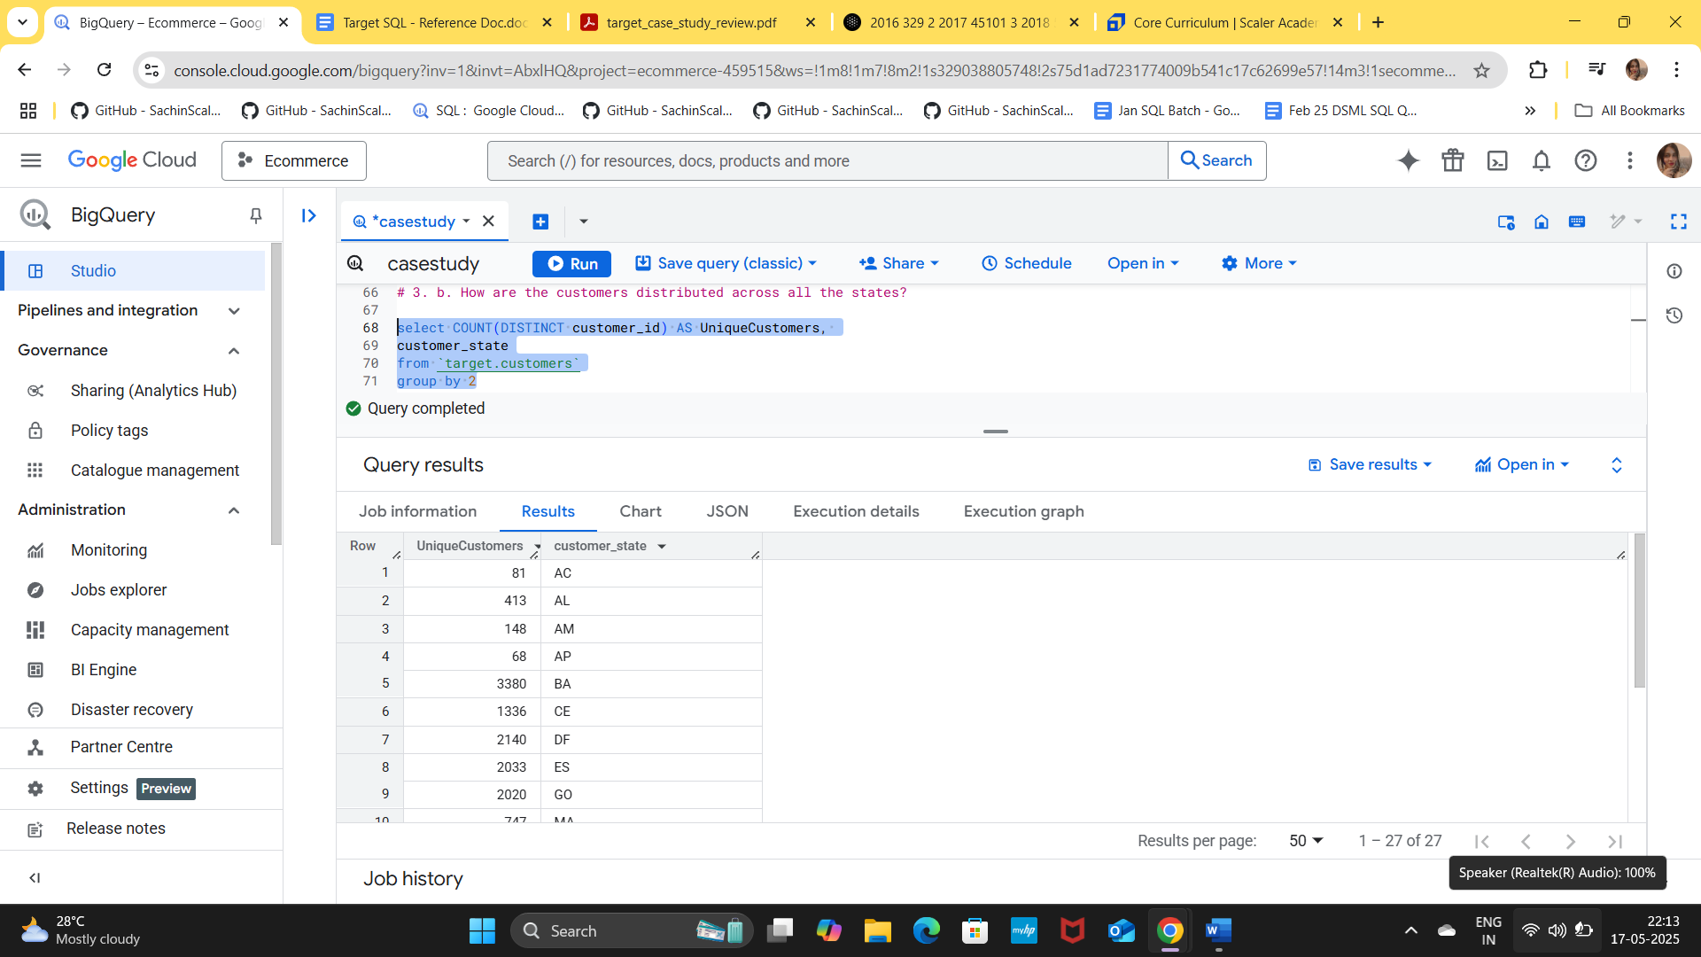

- Impact on Economy: Analyse the money movement by e-commerce by looking at order prices, freight and others.

- Get the % increase in the cost of orders from year 2017 to 2018 (include months between Jan to Aug only).
ANSWER:
with base_1 AS
( select *
from `target.orders` o
INNER JOIN `target.payments` p USING(order_id)
where extract(year from order_purchase_timestamp) BETWEEN 2017 AND 2018
AND extract(month from order_purchase_timestamp) BETWEEN 1 AND 8 ),
base_2 AS
( select
extract(year from order_purchase_timestamp) as year,
ROUND(sum(payment_value),2) as cost
from base_1
group by year
order by 1 ),
base_3 AS
( select *,
LEAD(cost) OVER(order by year) as nxt_year
from base_2 )
select *,(nxt_year - cost) / cost * 100 as percent_increase
from base_3;

INSIGHTS:
The overall percentage increase in the cost of orders from 2017 to 2018 is 138.53%, considering only the months from January to August. This significant rise indicates a notable shift in consumer spending patterns during that period.

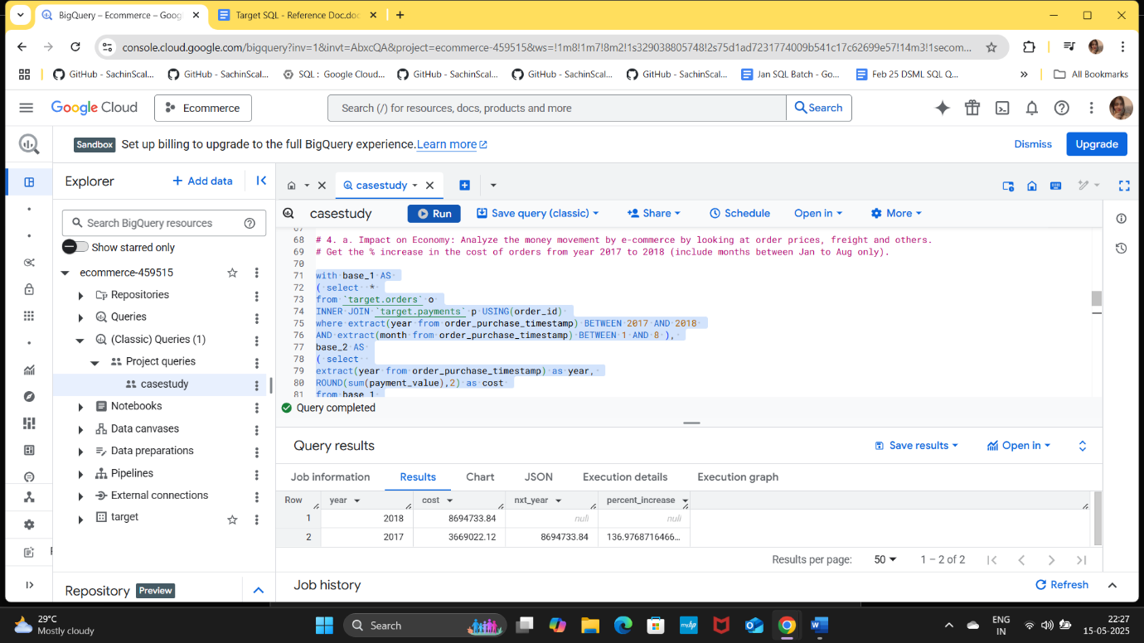

- Calculate the Total & Average value of order price for each state.

ANSWER:
select customer_state,
ROUND(sum(price),2) as total_price,
ROUND(avg(price),2) as avg_price,
from `target.orders` o
INNER JOIN `target.order_items` oi USING(order_id)
INNER JOIN `target.customers` c USING(customer_id)
group by customer_state
order by 2;

INSIGHTS:
- Total Order Prices: The state with the highest total order price is SP, indicating a significant volume of orders or higher-priced items in that region. RJ and MG also show substantial totals, suggesting strong market activity in those areas.
- Average Order Prices: The average order prices vary across states. AL has the highest average order price at 180.89, indicating potentially higher− value orders in that region. In contrast, SP has the lowest average order price at 109.65, which may suggest lower-priced items or smaller order sizes.

These insights can help in understanding pricing strategies and consumer behaviour across different states, as well as identifying regions with higher order values that may require further analysis or targeted marketing efforts.

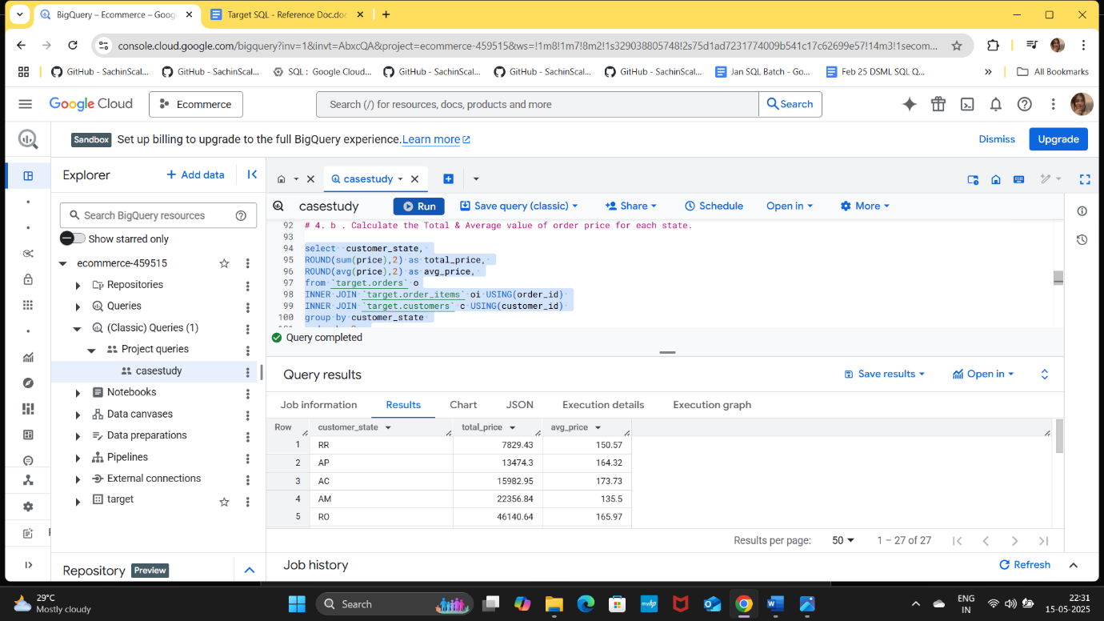

- Calculate the Total & Average value of order freight for each state.

ANSWER:
select customer_state,
ROUND(sum(freight_value),2) as total_freight_val,
ROUND(avg(freight_value),2) as avg_freight_val,
from `target.orders` o
INNER JOIN `target.order_items` oi USING(order_id)
INNER JOIN `target.customers` c USING(customer_id)
group by customer_state
order by 2;

INSIGHT :
- Total Freight Values: The state with the highest total order freight value is SP, indicating a significant volume of orders or higher shipping costs in that region. MG and RJ also show substantial totals, suggesting strong market activity.
- Average Freight Values: The average order freight values vary significantly across states. PB has the highest average freight value at 42.72, indicating potentially higher shipping costs or more expensive orders. In contrast, SP has the lowest average freight value at15.15, which may suggest lower shipping costs or smaller order sizes.
These insights can help in understanding shipping costs and pricing strategies across different states, as well as identifying regions with higher shipping expenses that may require further analysis or adjustments in logistics.

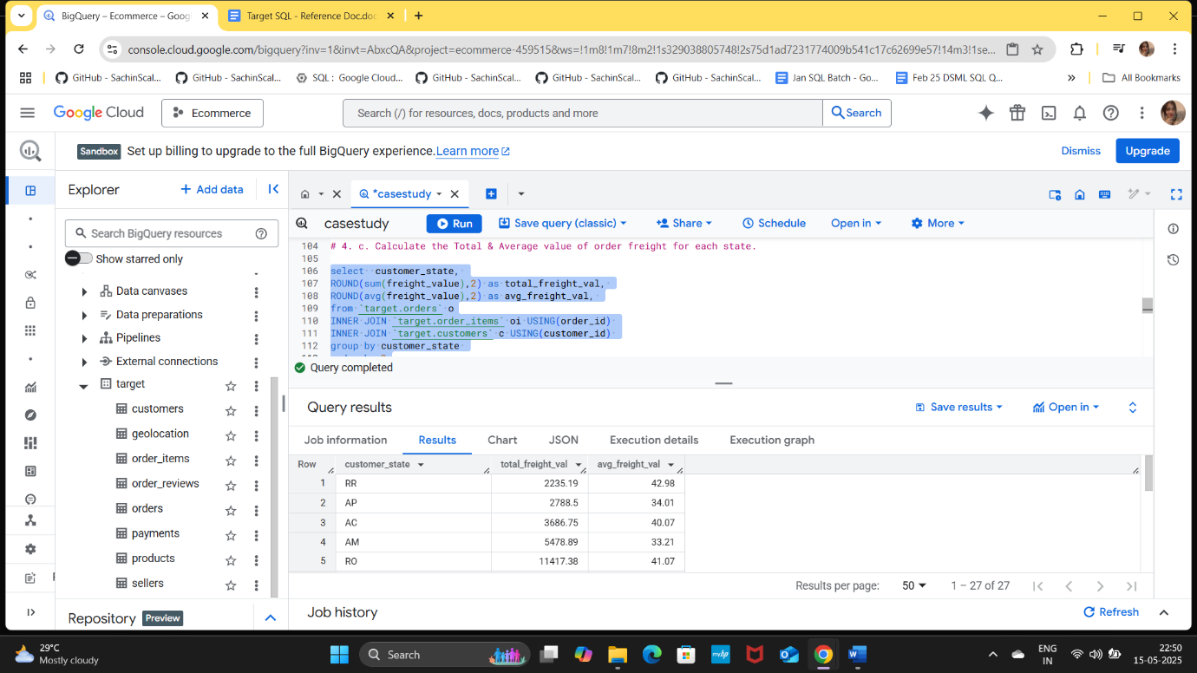

- Analysis based on sales, freight and delivery time.
  - Find the no. of days taken to deliver each order from the order’s purchase date as delivery time.
Also, calculate the difference (in days) between the estimated & actual delivery date of an order.
Do this in a single query.
Hint: You can calculate the delivery time and the difference between the estimated & actual delivery date using the given formula:
- time_to_deliver = order_delivered_customer_date - order_purchase_timestamp
- diff_estimated_delivery = order_delivered_customer_date - order_estimated_delivery_date

ANSWER:
select order_id,
TIMESTAMP_DIFF(order_delivered_customer_date,order_purchase_timestamp,DAY) as time_to_deliver,
TIMESTAMP_DIFF(order_delivered_customer_date,order_estimated_delivery_date,DAY) as diff_estimated_delivery
from `target.orders`
where order_status = 'delivered';

INSIGHT :

Positive Delivery Times:
  - This indicates efficient processing and delivery for this order.
Negative Delivery Times:
  - Several orders experienced delays, this suggests potential issues in logistics or processing for this order.
Overall Delivery Performance:
  - The majority of the orders in this dataset experienced delays, indicating a potential area for improvement in the order fulfilment process.
  - The presence of both early and delayed deliveries suggests variability in the delivery process, which could be influenced by factors such as order volume, shipping methods, or external conditions.

Here are a few Recommendations:

- Investigate Delays: Analyse the reasons behind the delays for the orders with negative delivery times to identify patterns or recurring issues.
- Enhance Efficiency: For orders that were delivered early, examine the processes that contributed to their timely delivery and consider applying similar strategies to other orders.
- Monitor Performance: Continuously track delivery times to ensure that improvements are made and maintained over time, aiming to reduce the number of delayed orders.

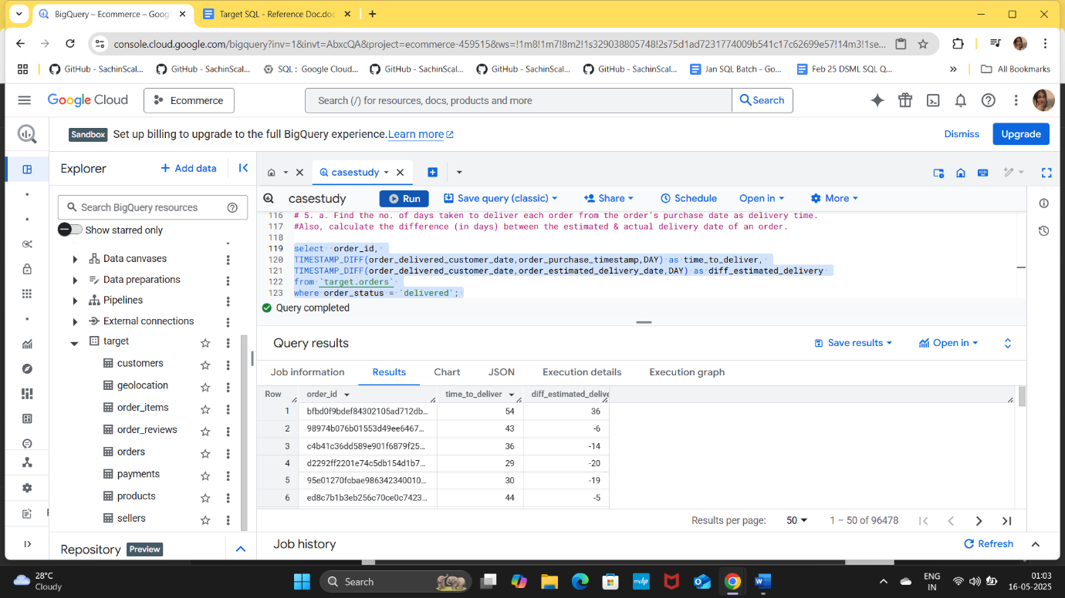

- Find out the top 5 states with the highest & lowest average freight value.

ANSWER:
( select customer_state, ROUND(avg(freight_value),2) as avg_freight_price,
from `target.orders`
INNER JOIN `target.order_items` USING(order_id)
INNER JOIN `target.customers` USING(customer_id)
group by customer_state
order by 2 desc
LIMIT 5 )
UNION ALL
( select customer_state, ROUND(avg(freight_value),2) as avg_freight_price,
from `target.orders`
INNER JOIN `target.order_items` USING(order_id)
INNER JOIN `target.customers` USING(customer_id)
group by customer_state
order by 2
LIMIT 5 );

INSIGHTS:
- The states with the highest average freight values (RR, PB, RO, AC, and PI) indicate that these regions may have higher shipping costs or are associated with more expensive orders.
- The high average freight values could suggest that these states either have longer shipping distances, higher shipping rates, or a greater proportion of high-value items being shipped.
- Businesses operating in these states may need to consider these costs when pricing their products or services, as higher freight costs can impact overall profitability.
- The states with the lowest average freight values (SP, PR, MG, RJ, and DF) suggest that shipping costs are relatively lower in these regions.
- SP has the lowest average freight value, which may indicate efficient logistics, shorter shipping distances, or lower shipping rates in that area.
- Businesses in these states may benefit from lower shipping costs, allowing for more competitive pricing or higher profit margins on products sold.

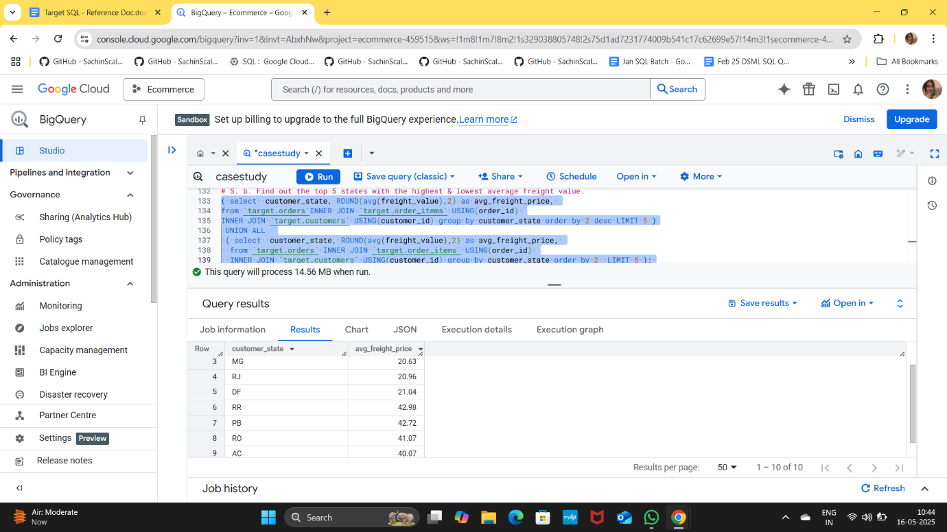

- Find out the top 5 states with the highest & lowest average delivery time.

Hint: We want you to find the top 5 & the bottom 5 states arranged in increasing order of the average delivery time.
ANSWER:
( select customer_state, avg(TIMESTAMP_DIFF(order_delivered_customer_date,order_purchase_timestamp,DAY)) as avg_time_to_deliver,
from `target.orders`
INNER JOIN `target.order_items` USING(order_id)
INNER JOIN `target.customers` USING(customer_id)
group by customer_state
order by 2 desc
LIMIT 5 )
UNION ALL
( select customer_state, avg(TIMESTAMP_DIFF(order_delivered_customer_date,order_purchase_timestamp,DAY)) as avg_time_to_deliver,
from `target.orders`
INNER JOIN `target.order_items` USING(order_id)
INNER JOIN `target.customers` USING(customer_id)
group by customer_state
order by 2
LIMIT 5 );

INSIGHTS:
- The states with the highest average delivery times (RR, AP, AM, AL, and PA) indicate that these regions experience longer shipping durations.
- The significantly high average delivery times in RR and AP may suggest logistical challenges, such as remote locations, limited transportation options, or higher shipping costs.
- Businesses operating in these states may need to manage customer expectations regarding delivery times and consider strategies to improve logistics efficiency.
- The states with the lowest average delivery times (SP, PR, MG, DF, and SC) indicate that these regions benefit from more efficient logistics and faster shipping processes.
- SP has the shortest average delivery time, which may be attributed to better infrastructure, proximity to distribution centres, or more efficient shipping routes.
- Businesses in these states can leverage their faster delivery times as a competitive advantage, potentially attracting more customers who value quick shipping.

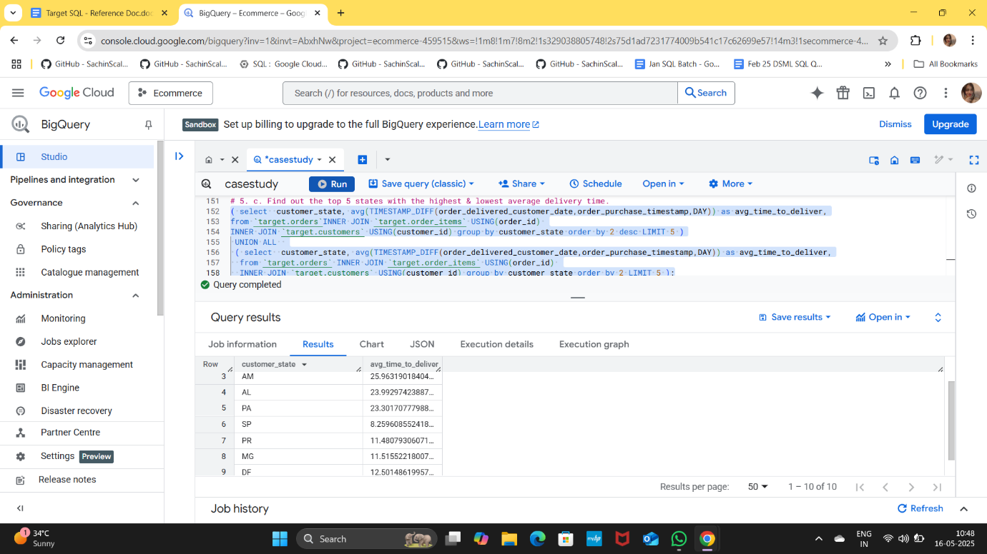

- Find out the top 5 states where the order delivery is really fast as compared to the estimated date of delivery.

You can use the difference between the averages of actual & estimated delivery date to figure out how fast the delivery was for each state.
ANSWER:
SELECT customer_state AS state,
ROUND(SUM(TIMESTAMP_DIFF(order_delivered_customer_date,
order_purchase_timestamp, DAY))/COUNT(ORDER_ID), 2) AS average_time_for_del,
ROUND(SUM(TIMESTAMP_DIFF(order_estimated_delivery_date,
order_purchase_timestamp, DAY))/COUNT(ORDER_ID), 2) AS average_est_dil_time,
FROM `target.orders` o
INNER JOIN `target.customers` c ON o.customer_id=c.customer_id
WHERE order_status='delivered'
GROUP BY customer_state
ORDER BY (average_time_for_del-average_est_dil_time);

INSIGHTS:
Delivery Speed Calculation:
  - The delivery speed was determined by calculating the difference between the estimated delivery time and the actual delivery time for each state. A positive difference indicates that the actual delivery was faster than estimated.
Top 5 States with Fastest Delivery:
  - The states with the fastest delivery times, where the actual delivery was significantly quicker than the estimated delivery, are as follows:
    - PR: With an actual delivery time of 11.53 days and an estimated time of 24.25 days, the delivery speed difference is 12.72 days.
    - MG: Actual delivery of 11.54 days against an estimated 24.19 days, resulting in a delivery speed difference of 12.65 days.
    - PB: Actual delivery of 19.95 days compared to an estimated 32.65 days, yielding a difference of 12.70 days.
    - PE: Actual delivery of 17.97 days versus an estimated 30.69 days, with a difference of 12.72 days.
    - MT: Actual delivery of 17.59 days against an estimated 31.37 days, resulting in a difference of 13.78 days.
In conclusion, the analysis of delivery times provides valuable insights into the efficiency of order fulfilment across various states. By focusing on the top-performing regions and addressing areas for improvement, businesses can enhance their delivery services and customer satisfaction.
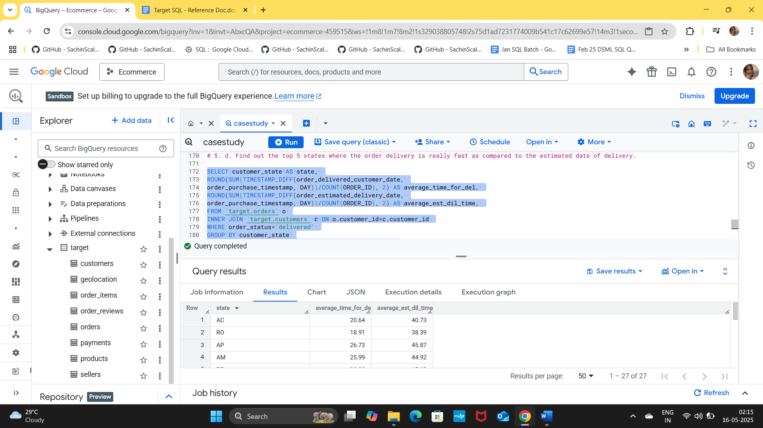

- Analysis based on the payments:
  - Find the month-on-month no. of orders placed using different payment types.

ANSWER:
select payment_type,
extract(year from order_purchase_timestamp) as yr,
extract(month from order_purchase_timestamp) as month,
count(o.order_id) as num_orders
from `target.payments` p
INNER JOIN `target.orders` o USING(order_id)
group by payment_type,yr,month
order by 2,3;

INSIGHTS:
  - The number of orders placed using each payment method remains relatively consistent across the months.
  - Credit cards and vouchers appear to be popular payment methods, with a significant number of high-value transactions (e.g., large amounts for credit card payments).
  - UPI and debit card transactions are also present but tend to have lower transaction values compared to credit cards and vouchers.
  - The data suggests a stable usage of different payment methods throughout the year, with credit cards being a preferred choice for higher-value transactions.
  - There is a balanced distribution of orders across all payment types, indicating that customers are comfortable using various methods for their purchases.

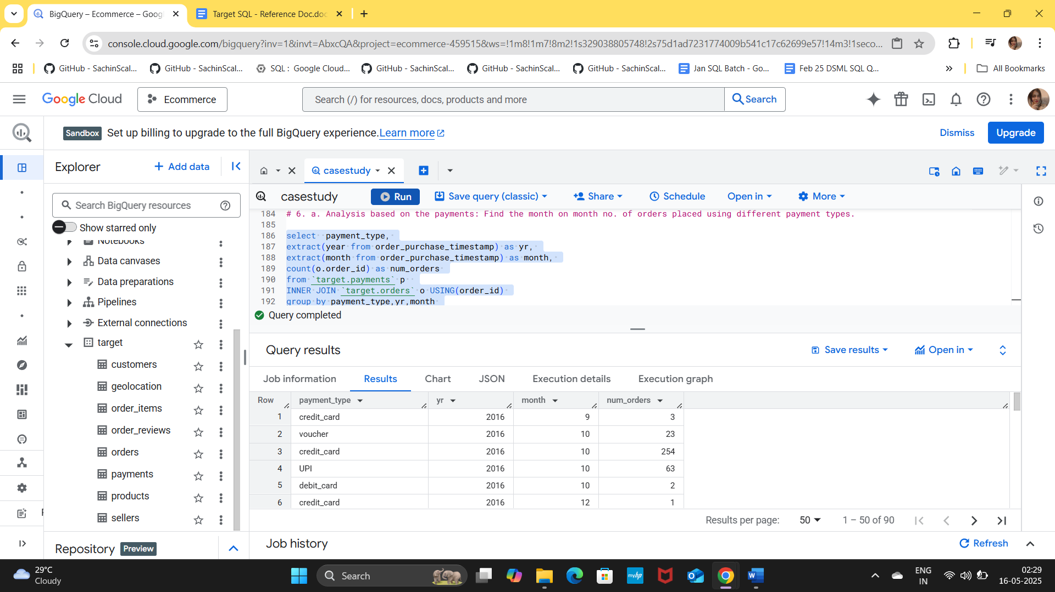

- Find the no. of orders placed on the basis of the payment installments that have been paid.
ANSWER:
select count(distinct order_id) as num_orders, payment_installments
from `target.payments`
where payment_installments >= 1
group by payment_installments;

INSIGHTS:
The data indicates a range of payment instalments associated with the number of orders placed. Analysing the figures reveals that higher instalment numbers correlate with a greater number of orders, while lower instalments show fewer orders. This trend suggests that customers may prefer to make larger payments upfront or in fewer instalments.

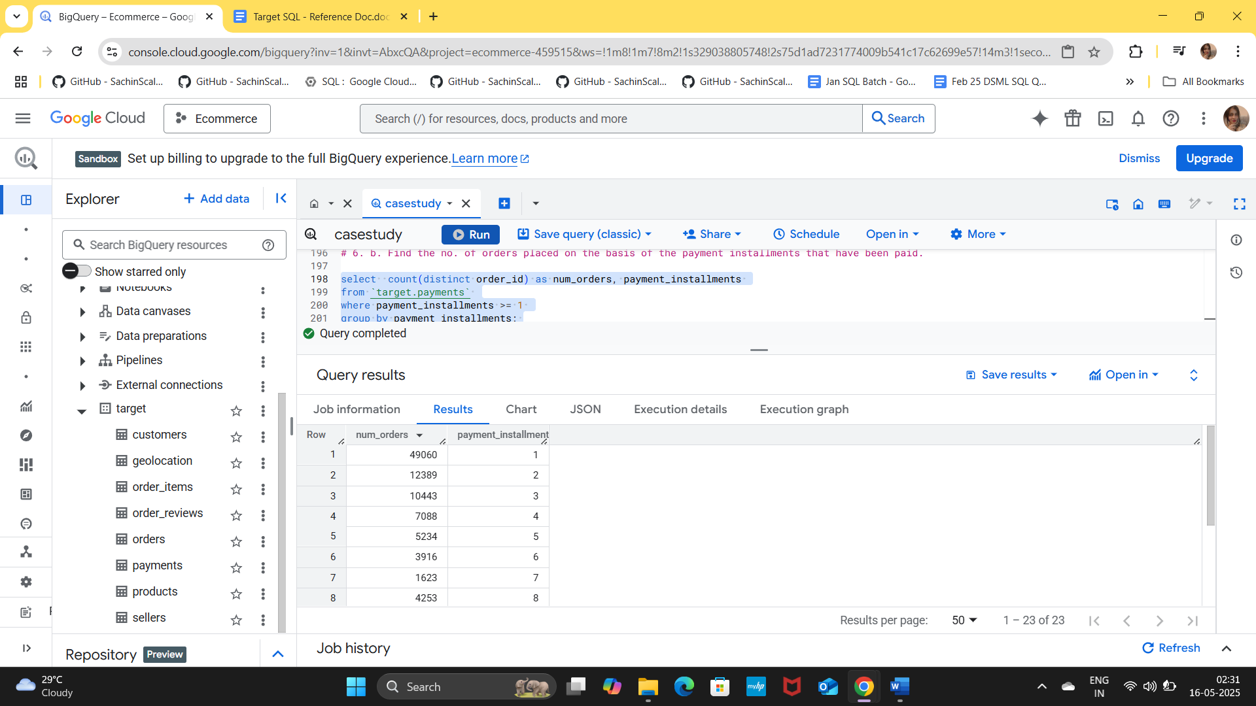

I. Basic Understanding
A. Data types
👉 Keep data clean and properly formatted so analysis is accurate and fast.
B. Order time range
👉 Use past data to predict future sales and plan inventory.
C. Customers by city/state
👉 Focus more on cities with many customers and try to grow in low-performing areas.

II. Detailed Analysis
A. Growth in orders
👉 Business is growing fast → increase stock, staff, and support.
B. Monthly trends
👉
- High months → keep more stock
- Low months → give discounts and offers
C. Time of day orders
👉
- Most orders come in afternoon & night
- Show ads and offers during this time

III. Regional Insights
A. Orders by state
👉
- Strong states → maintain service
- Weak states → run ads and improve delivery
B. Customer distribution
👉
- Focus on big states (more profit)
- Grow smaller states with offers

IV. Money & Pricing
A. Increase in spending
👉 Customers are spending more → sell premium products
B. Order price by state
👉
- High spending areas → sell expensive items
- Low spending areas → focus on affordable products
C. Freight cost
👉
- High shipping cost → reduce by improving logistics
- Offer free delivery on big orders

V. Delivery & Logistics
A. Delivery delays
👉 Fix delivery problems to avoid late orders and unhappy customers
B. Freight by state
👉 Reduce shipping cost in expensive areas by improving routes
C. Delivery time
👉
- Slow areas → improve delivery system
- Fast areas → use as advantage in marketing
D. Faster deliveries
👉 Improve delivery estimates so customers get more accurate timelines

VI. Payments
A. Payment methods
👉
- Promote popular options like cards
- Give offers on other methods to increase usage
B. Installments
👉
- Offer EMI options → helps customers buy expensive products

Final Simple Summary
👉 To grow the business:
- Focus on top cities and states
- Improve delivery speed
- Give offers in low sales months
- Reduce shipping costs
- Provide easy payment options

